W34KNESS VULHUB WALKHTROUGH
In this machine there a two person one is n30 (neo) where he have some privilege but we have to become the sudo root to control the world and save
So let’s get going and help n30
- Netdiscover
Using netdiscover to find the machine
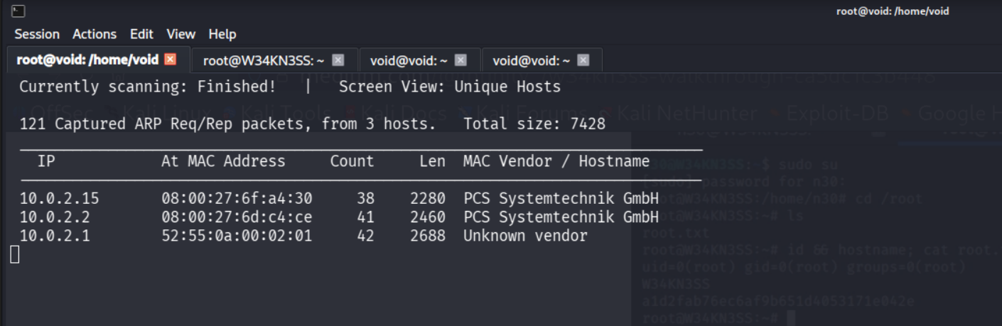
We have found the ip 10.0.2.15

- nmap
Using nmap to find where we have found that there are 3 services enable

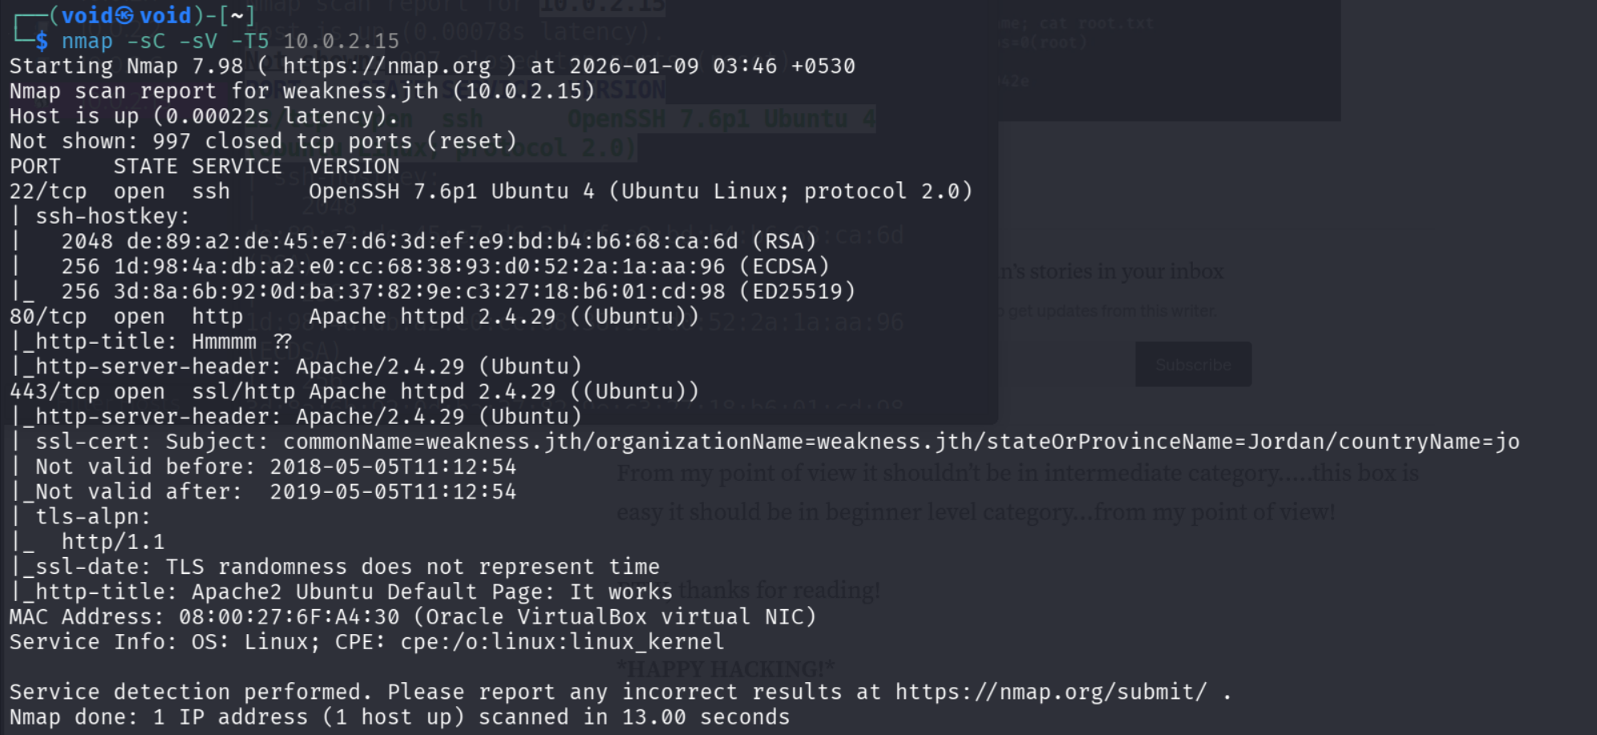

- Gobuster
Let’s use gobuster to find the directory
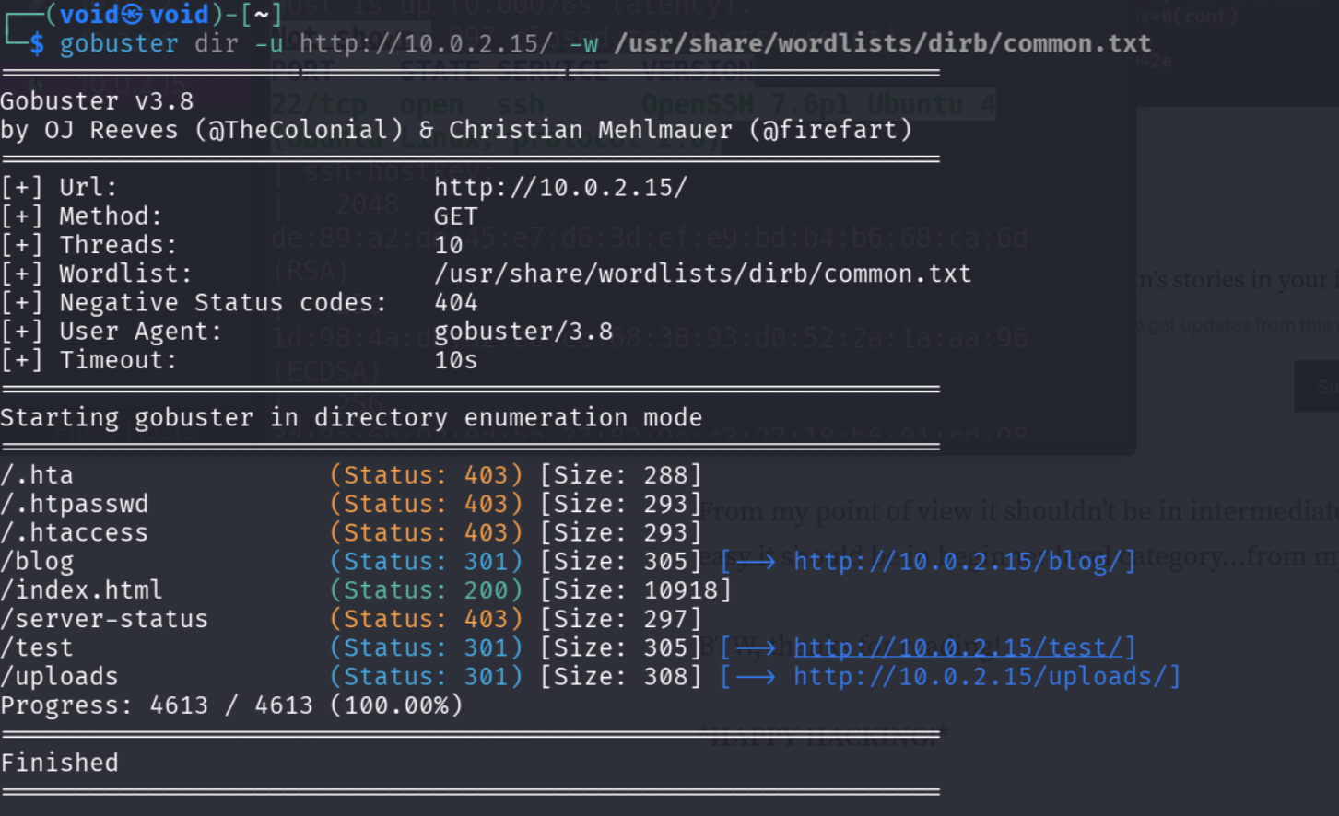

- 443 weakness.jth
I didn’t find anything special so while scoring through nmap command I found that it also uses 443 where weakness.jth is added
So after adding to my weakness.jth into my machine to run it through
Sudo nano /etc/hosts
(machine ip) weakness.jth
So it’s ready to go so let’s open it
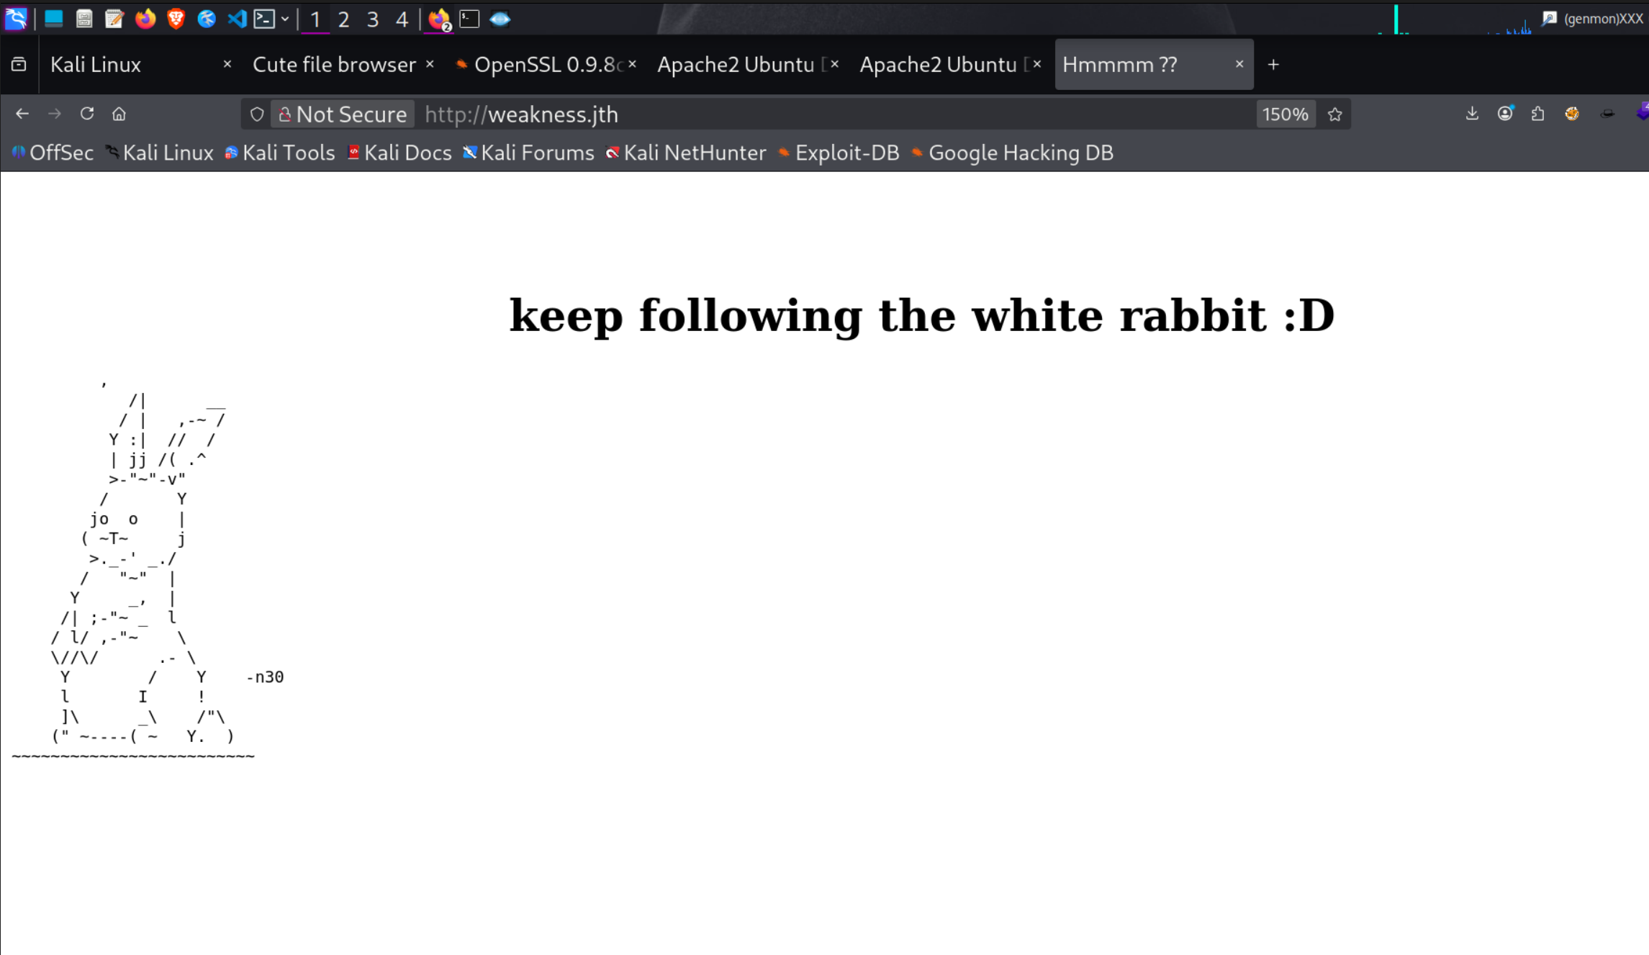
So let’s add see what does this got
So let’s use gobuster to see what this had offer to us
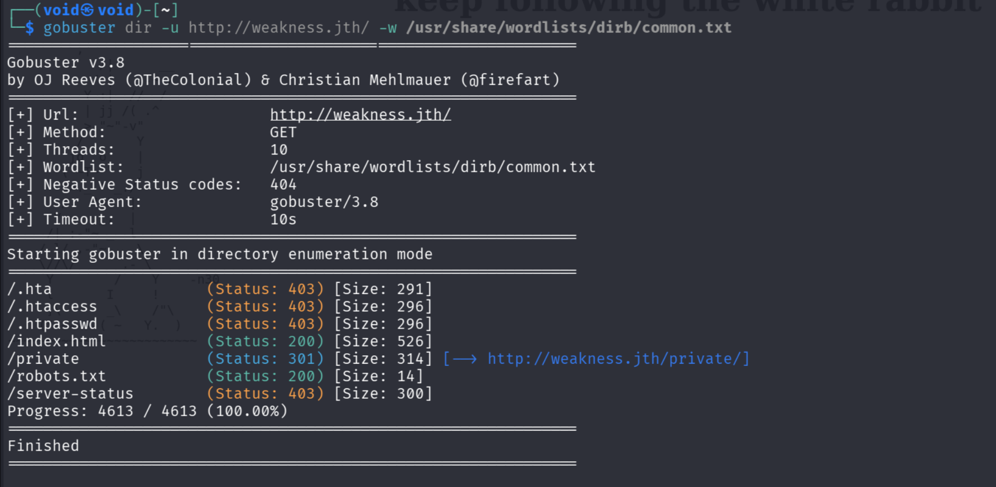

OHH /private is there let’s go what it has offered to us
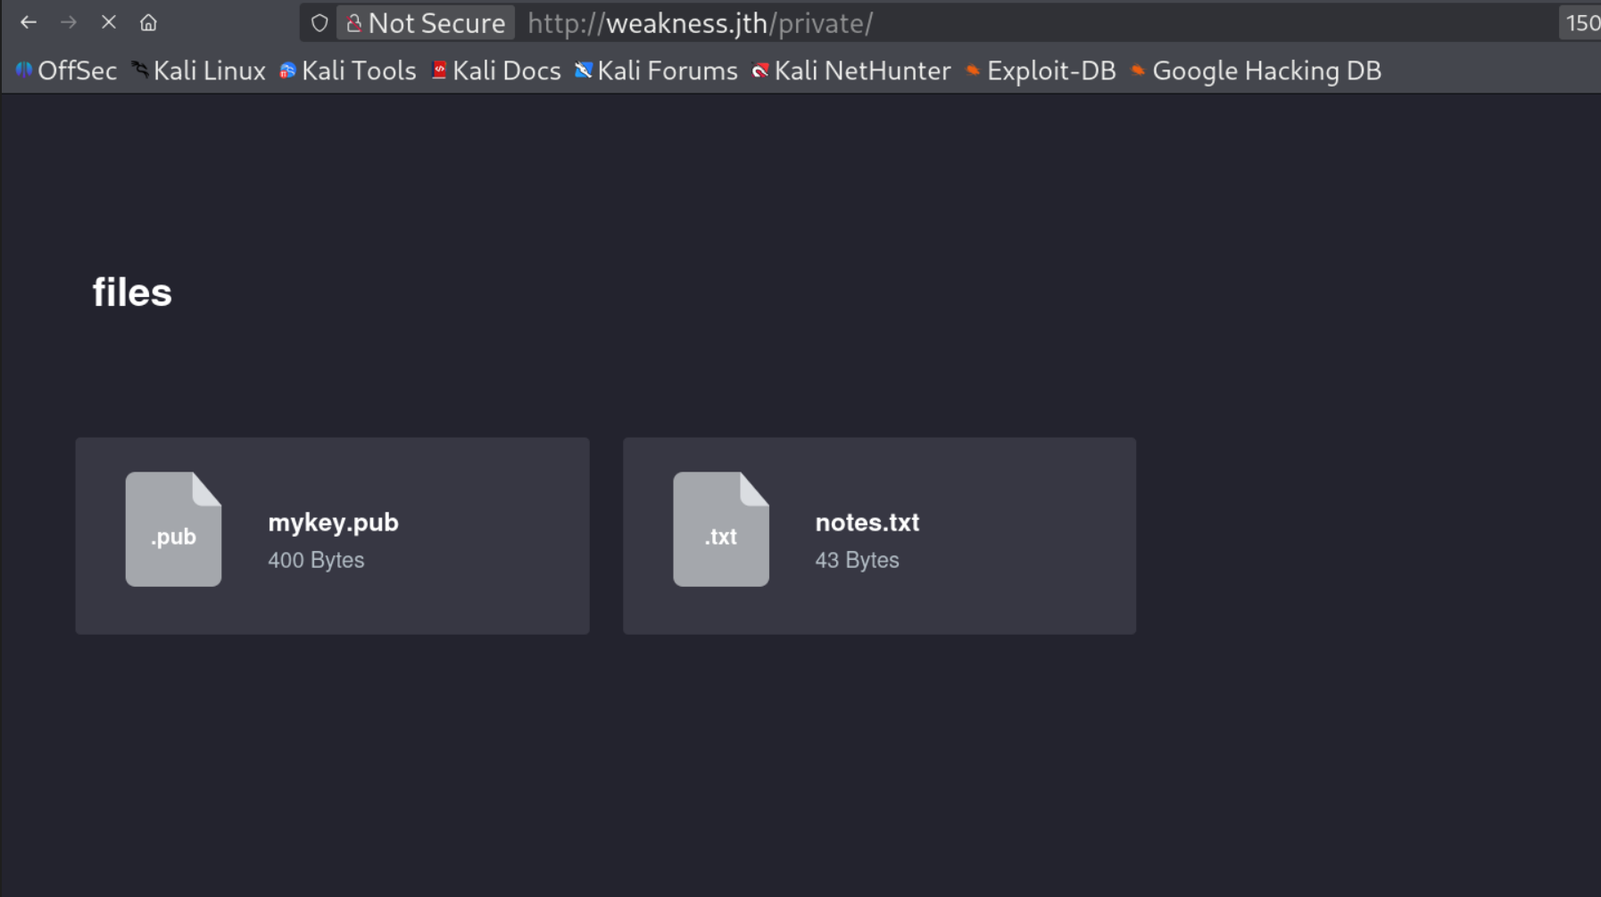

- wget commands
So let’s add this to to file to see what is this??
wget http://weakness.jth/private/files/mykey.pub
wget http://weakness.jtj/private/files/notes.txt
So I opened notes.txt
Where it is given which key algorithm is using which is not supposed to given

- 5622.txt
Now I have google it and found out exploit db
So kali have a build it tool that is searchsploit
So after using searchsploit we found out there is a gitlab and I have downloaded it
So it’s has zip file ( you can use 7z or tar )
So it gives us /rsa/2048
So it’s has two options which is the python which was given but you have to add all the elements & after googling some thing there is a grep command also
So I have chosen grep one and we also have the different file that is mykey.pub
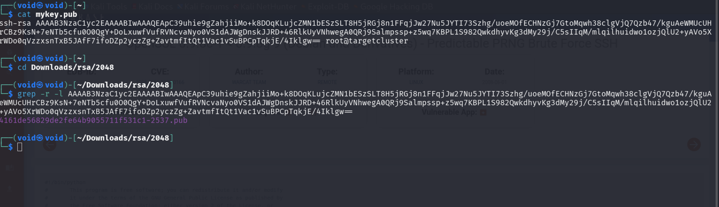
So it given a rsa key

- ssh -i
Let’s just try this to use ssh because it has given rsa key with ssh uses
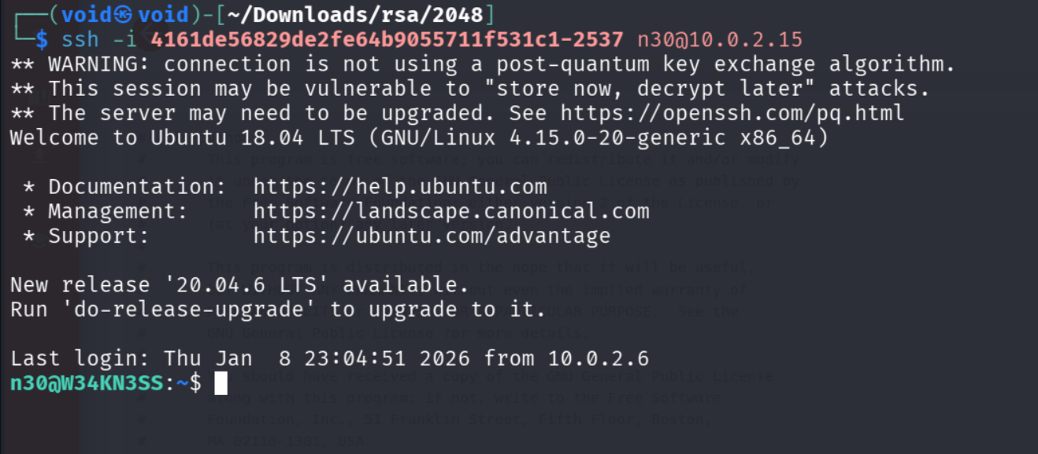
So let’s go half part is done

- code (file python 2.7 byte-compile)
It has give a code file I have to downloaded it using wget
How I do it I have added this to file to /var/html/
So after using file code command it has given me python 2.7 byte-complied
So If you first uses open it, it should be have code file not the code.pyc
So just add command mv code code.pyc
It will now be opened

So let’s talk about what is the byte file when you run a python command it also create byte-compile so it’s like a translator but for the computer
So we cannot run but it can be complied again
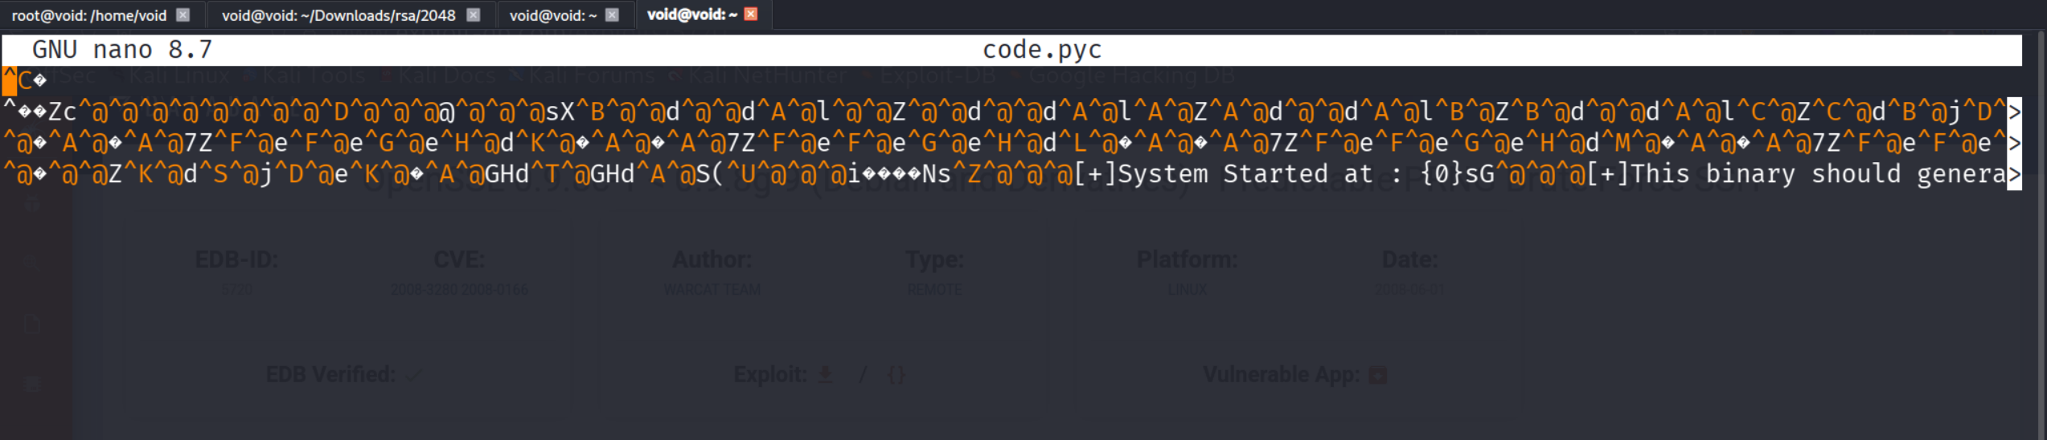

- using decomplier file uncompyle6
So python has decomplier file called uncompyle6
So use command
Pip install uncomplye6
So let’s talk first what is uncompyle6 it is a make a file for the environment not it does not make but in environment for some moment of time
So let’s just use uncompyle6
Uncompyle6 .pyc
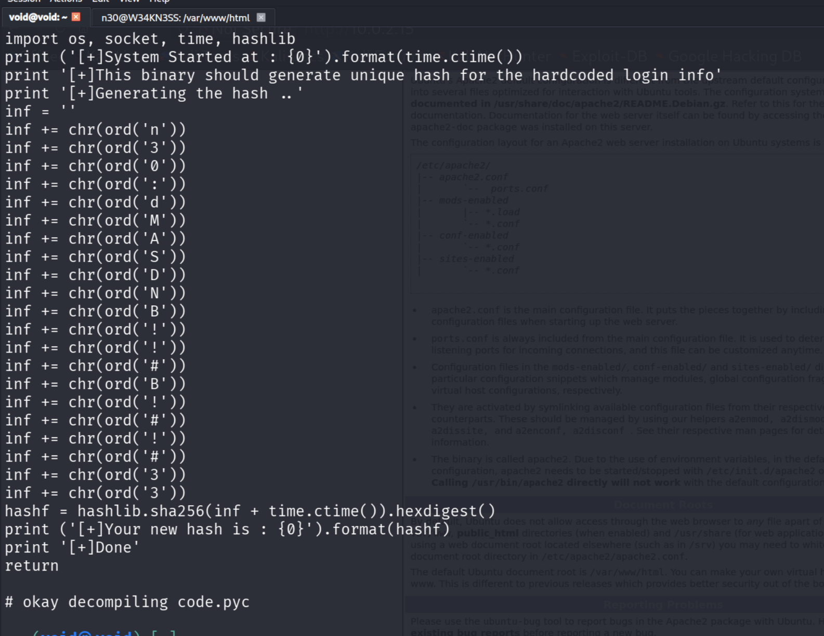

- exploit
It has given me some interger
Now to normal
n30 : dMASDNB!!#B!#!#33

so let’s just try this password bcauz it looks like password
so add
sudo -i
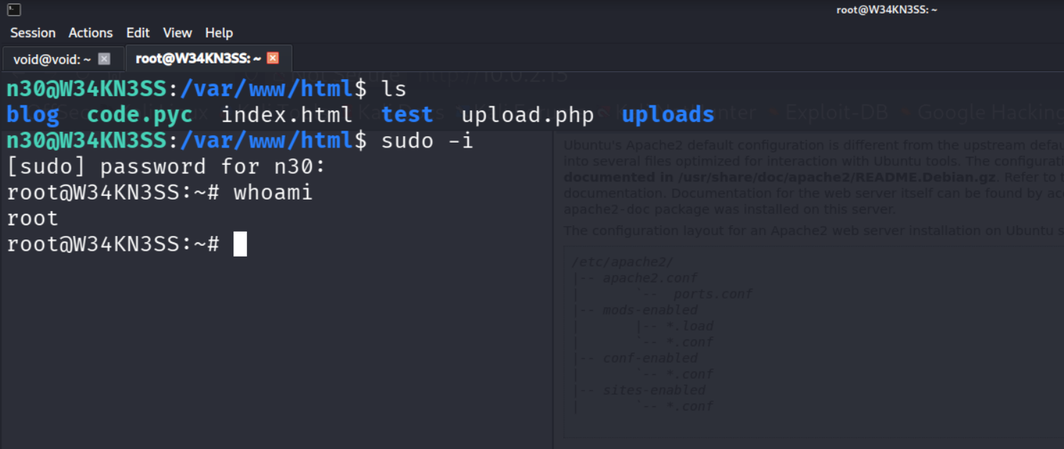

Horray We have helped neo or n30 to hack into root to become the world now he is hero

